Specific CPU Architectures Application

Universal vs Special APK
Universal APK |  | Specific ABI APK
When building APK, default, build system include the binaries for each ABI in a single APK. This is universal APK. |  | Specific ABI APK contains only the binaries for its ABI.
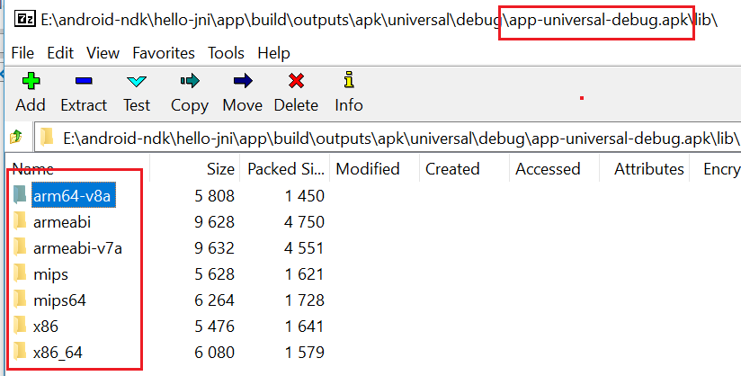 |  | 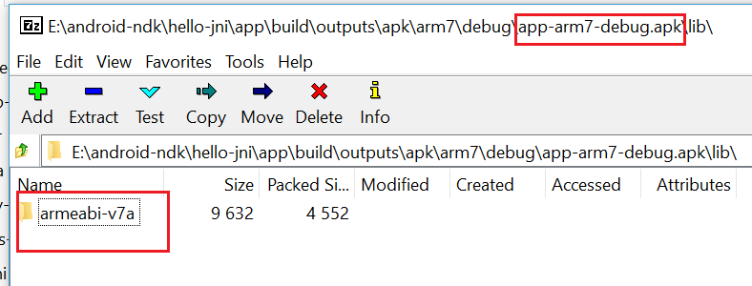

Splits Block
Splits is a Gradle configuration to build multiple APKs in a single project. Each generated APK contains only code and resources specific for density or ABI.

Use Splits Block To Specify ABI
Add splits block to your module-level build.gradle file.

android {
splits {
abi {
enable true //enable Gradle generates APKs based on ABI
reset() //clear target ABI list
include <abi> //detemine target ABIs
universalAPK false //avoid generate universal APK
}
}
}

For example, you need to build x86 only.
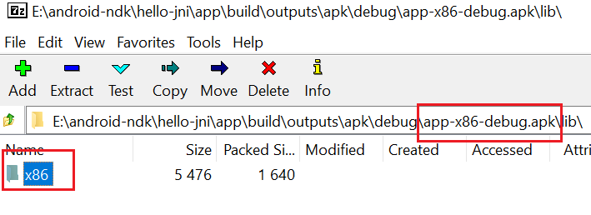  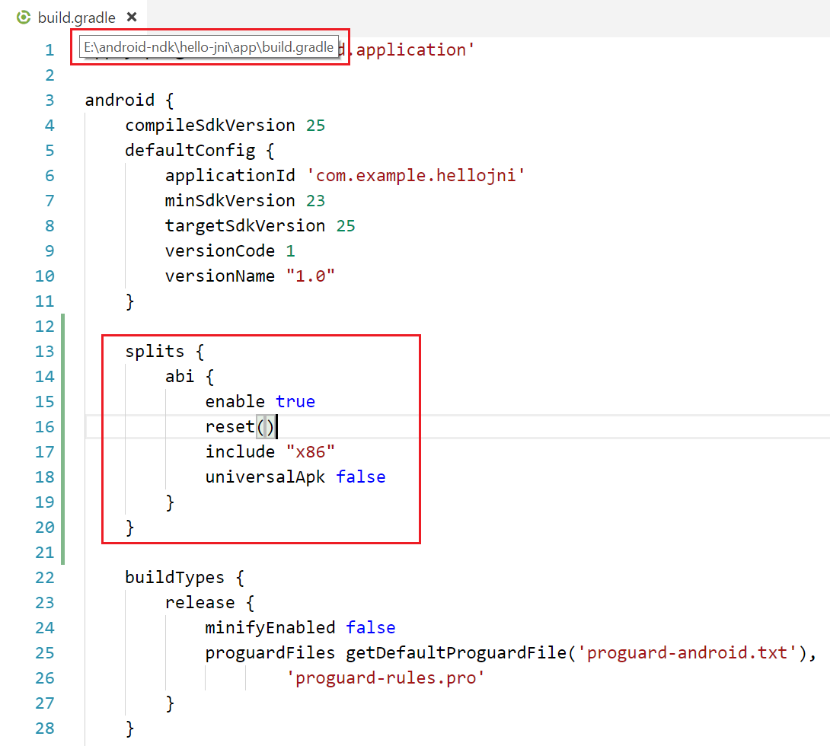 | 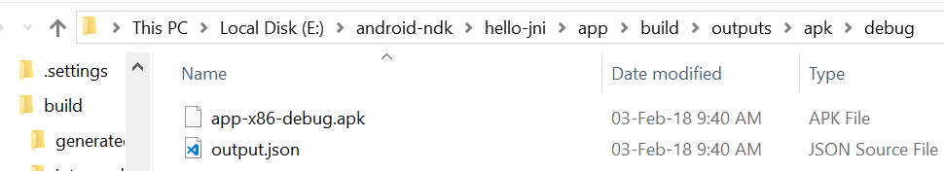  Only x86 apk is generated.  Only x86 binary is packed in apk.

You need to build x86 and armv7 only.
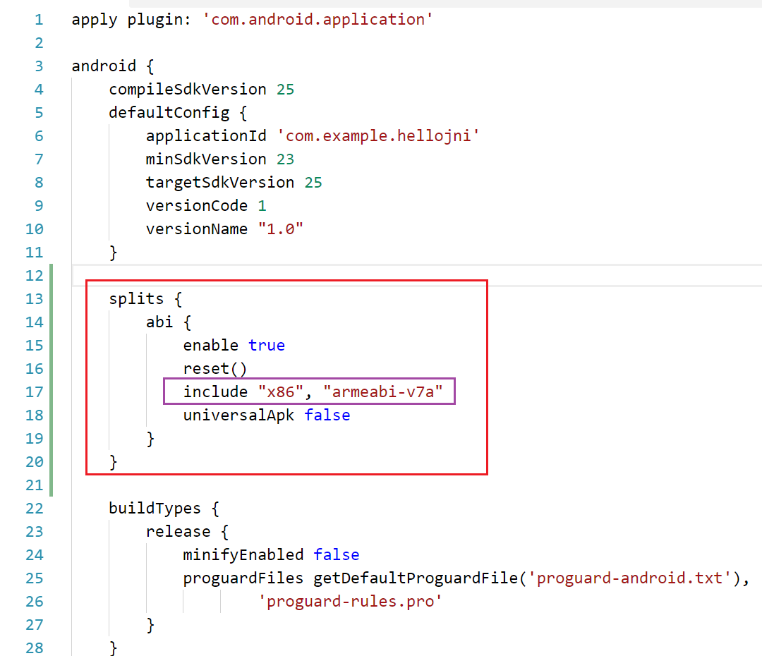 | Only x86 and armv7 apk are generated.  